1. Most historians consider Alexander Hamilton to have been a successful Secretary of the Treasury because he (1.01)
A expanded trade with all nations
B established a sound financial plan for the new nation
C eliminated tariffs between the states
D opposed payment of previous federal government debts

2. As Secretary of the Treasury, Alexander Hamilton was most noted for (1.01)
A devising a plan to pay off the nation’s debts
B beginning a system to tax exports
C arranging necessary loans from European nations
D raising revenue from the sale of western lands

3. One major reason that Alexander Hamilton proposed a national bank was to (1.01)
A improve the economic position of the United States government
B help state governments collect taxes
C make loans available to owners of small farms
D reduce foreign investment in the United States

4. One reason James Madison and Thomas
Jefferson objected to Alexander Hamilton’s financial policies was that they believed (1.01)
A the establishment of a national bank was unconstitutional
B a laissez-faire policy would not help the country’s economy
C the government should encourage industrial development
D high tariffs were needed to protect America’s economic interests

5. Which action during Washington’s administration led to the Whiskey Rebellion in western Pennsylvania? (1.01)
A passage of a new excise tax
B establishment of a presidential cabinet
C creation of the Bank of the United States
D ban on slavery in the Northwest Territory

6. Conflicts between Jeffersonians and Hamiltonians during President George Washington’s first administration led directly to the (1.01)
A end of the Era of Good Feelings
B decision to replace the Articles of Confederation
C addition of the elastic clause to the Constitution
D start of the first political parties

7. • Alien and Sedition Acts
• Virginia and Kentucky Resolutions

These pieces of legislation reflected the conflict between (1.01)
A Congress and the president
B states’ rights and federal supremacy
C the military and the civilian government
D the United States Supreme Court and state courts

8. The decision in Marbury v. Madison (1803) expanded the power of the Supreme Court by (1.01)
A restricting the use of the elastic clause
B establishing the power of judicial review
C upholding the constitutionality of the
National Bank
D interpreting the interstate commerce clause

9. How did Supreme Court decisions under Chief Justice John Marshall affect government in the United States? (1.01)
A Federal power increased at the expense of the states.
B Strict limits were placed on congressional use of the elastic clause.
C The impeachment of federal judges was declared unconstitutional.
D State powers under the 10th Amendment were expanded.

10. On what grounds would strict constructionists of the United States Constitution have questioned the purchase of the Louisiana Territory? (1.01)
A It violated the guarantee of states’ rights.
B The president was not specifically given the power to purchase new land.
C Congress was opposed to expansion west of the Mississippi River.
D The Constitution applied only to the original thirteen states.

11. How did President George Washington react to the conflict between France and England in 1793? (1.03)
A He used the opportunity to begin the war for American independence.
B He declared the neutrality of the United States.
C He aided the French because they had supported the American Revolution.
D He negotiated a peace settlement between the warring nations.

12. “’Tis [It is] our true policy to steer clear of permanent alliances with any portion of the foreign world. . . .”
— President George Washington, Farewell Address, 1796

The United States was able to follow this advice from President Washington for several decades primarily because of (1.03)
A industrial and agricultural self-sufficiency
B strong support from other Western Hemisphere nations
C geographic isolation from Europe
D peaceful relations between the European powers

13. The foreign policies of George Washington, Thomas Jefferson, and James Madison were similar in that they each (1.03)
A supported wars against England
B failed to acquire new territory
C attempted to avoid involvement in European affairs
D aided the French in return for their help during the Revolutionary War

14. The First Amendment states that “Congress
shall make no law abridging the freedom of
speech, or of the press.” Which best explains
the meaning of this part of the First
Amendment?
A. People can speak aloud or publish all they
want to under all circumstances.
B. The Government cannot punish people for
speaking aloud or publishing any true fact or
any opinion
C. People can speak out in Congress without
being arrested.
D. Members of Congress can speak freely.
On debate without fear of punishment.

15. What was the most important effect of the
cotton gin?
A. It caused a boom in the cotton harvest that
increased the need for slaves.
B. It caused a firm alliance between Britain and
Southern cotton planters.
C. It causes the South to be a more prosperous
region than the North.
D. It caused territorial expansion from the
South to the Midwest.

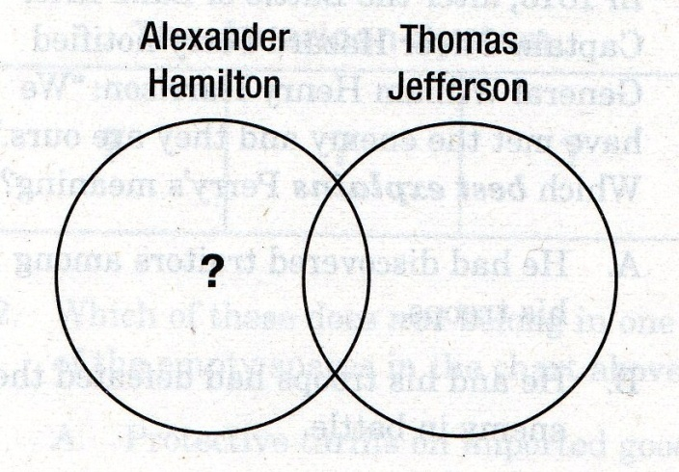
16. Which best replaces the question mark in the Venn diagram above?
A. Author of some of the Bill of Rights.
B. Member of the Democratic-Republican Party
C. Supporter of strict interpretation of the
Constitution.
D. Supporter of loose interpretation of the
Constitution.
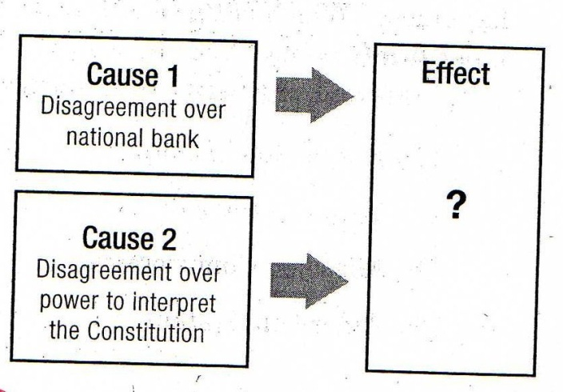

17. Which best completes the cause and effect
chart?
A. Re-election of George Washington as president.
B. Election of John Adams as president
C. Development of a two-party political
system
D. Ratification of the Bill of Rights

18. Jay’s Treaty was to the United States and Britain as the Convention of 1800 was to
A. The U.S. and France
B. The U.S. and Spain
C. The U.S. France and Britain
D. France and Britain

19. Which best explains Tecumseh’s reason for
siding with Britain in the War of 1812?
A. The U.S. Government had continually lied to and betrayed the Indians.
B. Tecumseh knew in advance Britain was going to win the war.
C. Britain agreed to allow the Indians to keep their ancestral lands.
D. The U.S. had forced the Indians to march along the Trail of Tears to reservation.

20. Two long-lasting precedents set by President Washington were
- cabinet reorganization and treaty-making
- receiving ambassadors and using the militia
- state of the union message and power to pardon
- two-term presidency and neutrality in foreign affairs

21. Which of the following events led to the immediate end of the Federalist Party?
- The Alien and Sedition Acts
- The Election of 1800
- The Hartford Convention
- The XYZ Affair

22. How are the initial suffrage requirements
of the young United States best summarized?
- Only males could vote.
- Only white males could vote.
- Only white male property owners could vote.
- Only northern white males owning property could vote.

23. How would the term “embargo” best be
described?
- A tax on trade
- A ban on trade
- An agreement to stop war
- An agreement to trade only certain goods

24. What would most likely happen if the Treaty of Ghent had reached the United States immediately?
- The Battle of New Orleans would not have happened.
- Andrew Jackson would never have become president?
- The impressments of sailors would have continued for years
- The United States and Great Britain would have continued fighting.

25. What was the most significant outcome of the X,Y,Z Affair for Americans?
- They no longer trusted the French.
- They no longer trusted the British.
- They felt mistreated by the French demand for money.
- They become angry at the French demand for money.

26. “Nothing is more essential than that permanent, habitual hatred against particular nations and passionate attachments for others should be excluded.” Which best describes the policy George Washington was advocating for the United States in his farewell address?
- Neutrality
- Imperialism
- Militarism
- Nationalism

27. Jefferson’s belief that the United States must acquire the port of New Orleans from France resulted in which Action?
- The War of 1812
- The Louisiana Purchase
- The Virginia and Kentucky Resolutions
- The Alien and Sedition Acts

28. Which best describes the lasting constitutional principle established in
Marbury v. Madison?
- The Supreme Court has the authority to decide a law’s constitutionality.
- The laws made by Congress do not apply to the president of the United States.
- Americans are free to express their own opinions at all times.
- Any person convicted in a lower court has the right to appeal to a higher court.
29. Which best describes an important result of middle-class women’s involvement in clubs and church groups in early nineteenth-century America?
- A greater number of patents for women inventors.
- The beginning of strict laws governing women’s activities.
- The beginning of social welfare movements such as temperance and abolition.
- An increase in credit for women, such as bank loans and store accounts.

30. Which European nation signed two treaties with the United States, giving it Florida and opening the Mississippi Valley to farmers?
- France
- Spain
- Great Britain
- Switzerland

31. The Virginia and Kentucky Resolutions were based on which principle?
A. the states’ right to nullify acts of the federal government
B. the Supreme Court’s right to nullify acts of Congress
C. Congress’ right to nullify acts of the states
D. the president’s right to nullify rulings of the Supreme Court

32. What is the significance of Pinckney’s Treaty (1795) with Spain?
A. It gave the United States the right to navigate the Mississippi.
B. It gave the United States most-favored nation status.
C. It allowed Lewis and Clark to explore the Louisiana Territory.
D. It moved the Shawnee to the Indiana Territory.

33. What was the intent of the Embargo Act and why did it fail?
A. It was meant to help Great Britain in its war with France without requiring the US to commit military personnel to the conflict, but it failed because US troops inevitably became involved in the fighting.
B. It was a response insult to the XYZ Affair but it failed because the US did not have the military strength to back up its actions.
C. It was meant to avoid war by forbidding trade between the US and foreign nations, thus preventing the impressments of US sailors. It failed, however, because it had little effect on Great Britain and hurt the US economy by damaging business.
D. It was meant to keep the French and British from establishing future colonies in the Western Hemisphere, but it failed because Great Britain’s navy was too powerful for the US to resist.

34. Which of the following did Alexander Hamilton favor as part of his economic plan?
A. prohibiting taxes on products such as whiskey
B. closing the national bank
C. protective tariffs
D. requiring state governments to pay off their own war debts

35. The earliest political party that favored strong state governments, looked to Thomas Jefferson as its leader, opposed Hamilton’s plan and favored the interests of farmers was which of the following?
A. The Federalists
B. The Democrats
C. The Democratic-Republicans
D. The War Hawks

36. “remember the ladies and be more generous and favorable to them than your ancestors. "Do not put such unlimited power into the hands of the husbands. "Remember, all men would be tyrants if they could. If particular care and attention is not paid to the ladies, we are determined to foment a rebellion, and will not hold ourselves bound by any laws in which we have no voice or representation.”
The above quote comes from whom?
- The wife of a southern plantation owner demanding the right of equal pay.
- Martha Washington demanding that women be allowed to run for public office.
- Abigail Adams demanding that women be granted suffrage.
- Dolly Madison demanding that women be granted the right to free speech.

37. The Treaty of Greenville is an example of which of the following trends in early US history?
A. the fact that women and minorities could not vote
B. The tendency of the US to become involved in conflicts with Great Britain.
C. the inability of the Spanish to maintain control of territories in America.
D. The fact that Indians continually lost land to white settlers.

38. Which of the following contributed to the outbreak of the War of 1812?
A. The XYZ Affair
B. Impressment
C. Neutrality
D. Pinckney’s Treaty

39. George Washington opposed which of the following?
A. any connection between government and religion
B. Hamilton’s Economic Plan
C. political parties
D. federalism

40. Which of the following was considered a “necessary evil” and was not abolished despite the fact that it seemed to contradict the principles of the Declaration of Independence?
A. the formation of political parties
B. the institution of slavery
C. attacks on Indians
D. the Embargo Act

